Answer of the following Questions

1.You Need to Calculate the monthly Sales and identify which month has the highest sales and which month has the lowest sales

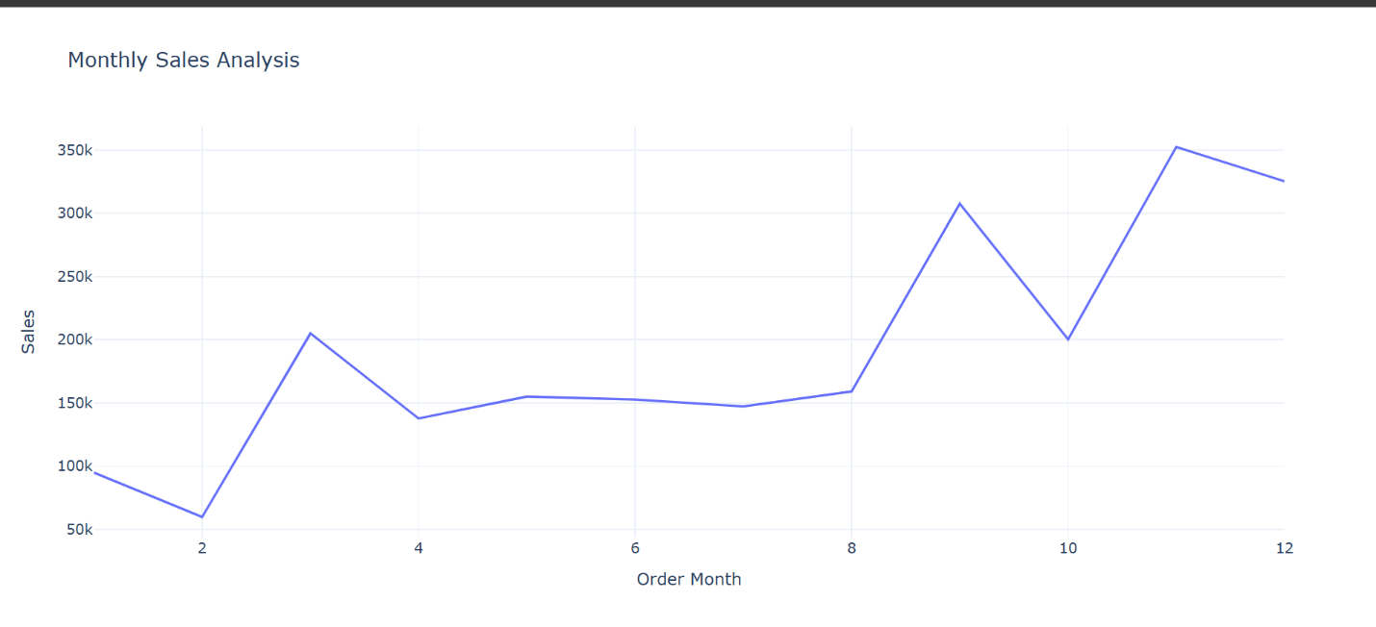

Highest sales-November

Lowest sales-February

2. You need to analyze sales based on product categories and determine which category has the lowest sales and which category has the highest sales.

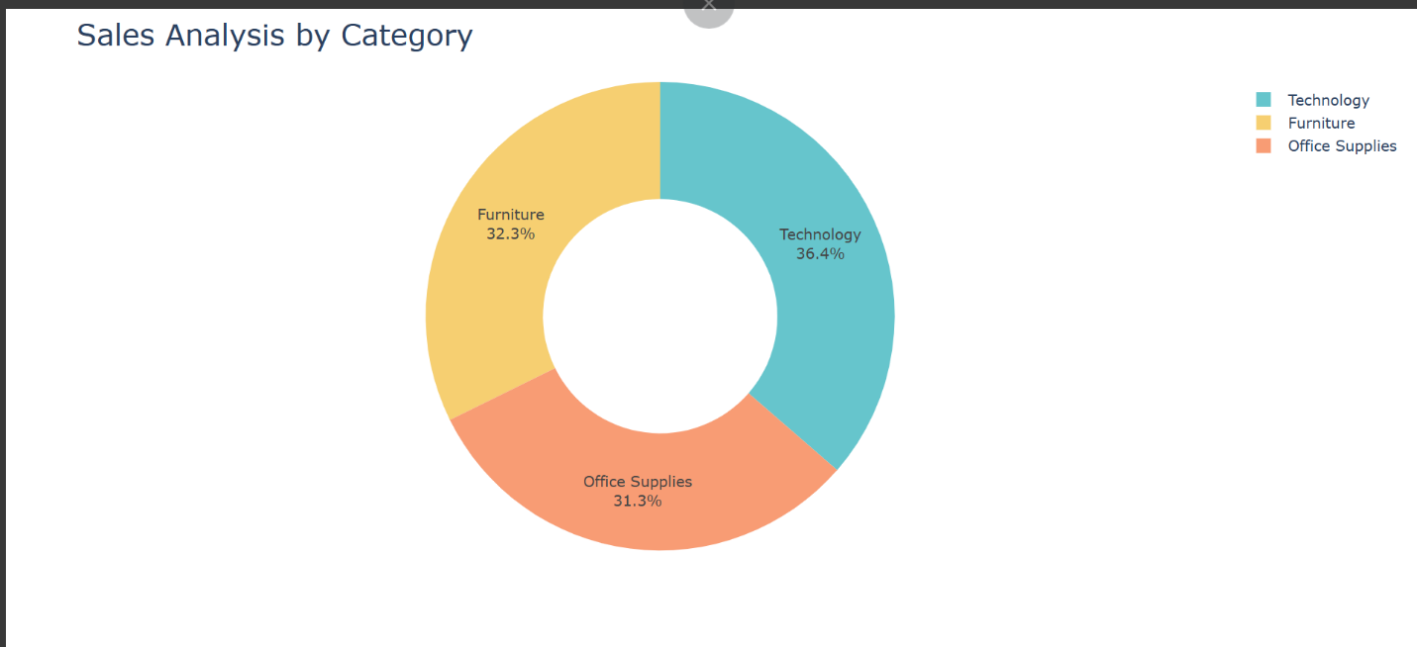

Technology

3. The sales analysis needs to be done based on sub-categories

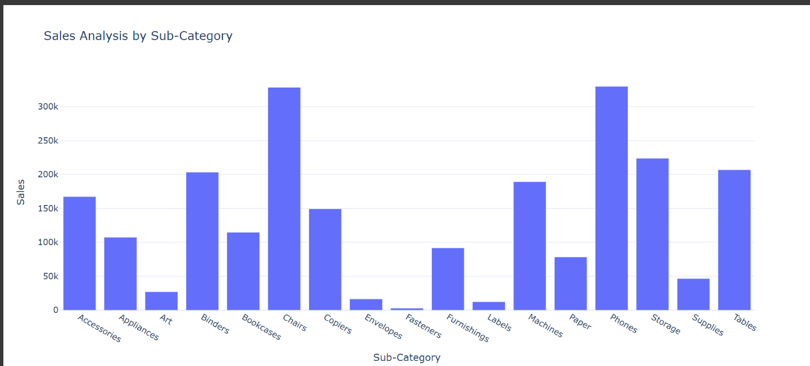

Chairs and Phones

4. You need to analyze the monthly profit from sales and determine which month had the highest profit

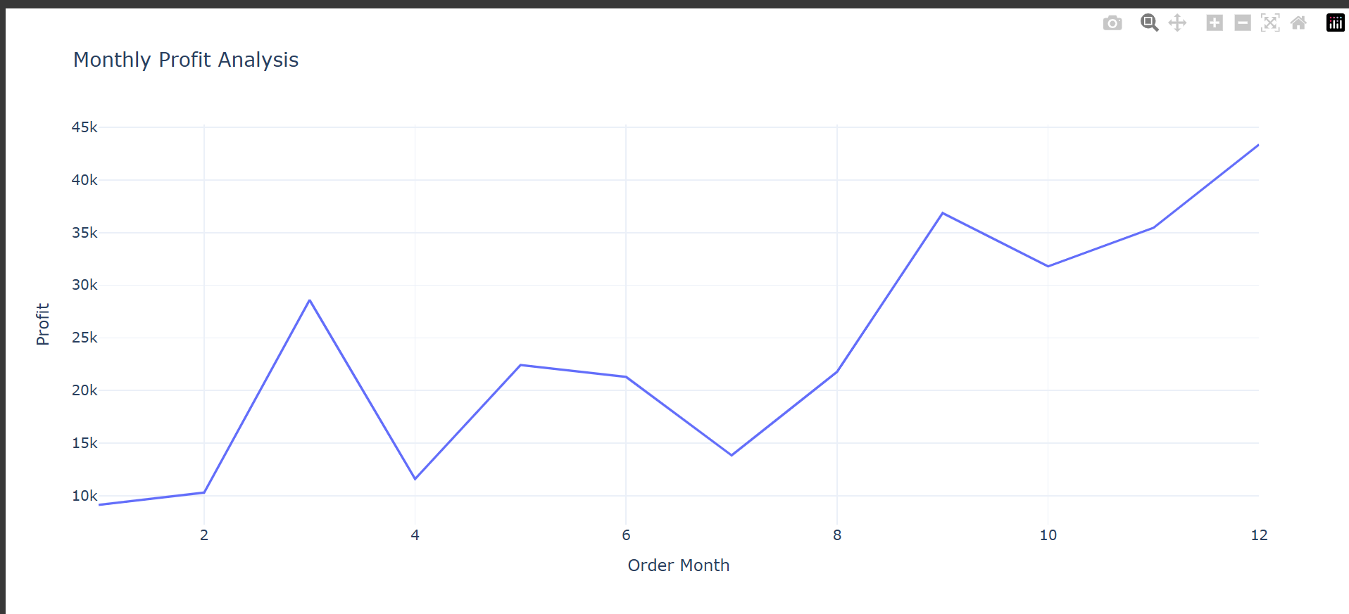

December

5. Analyze the profit by category and sub-category

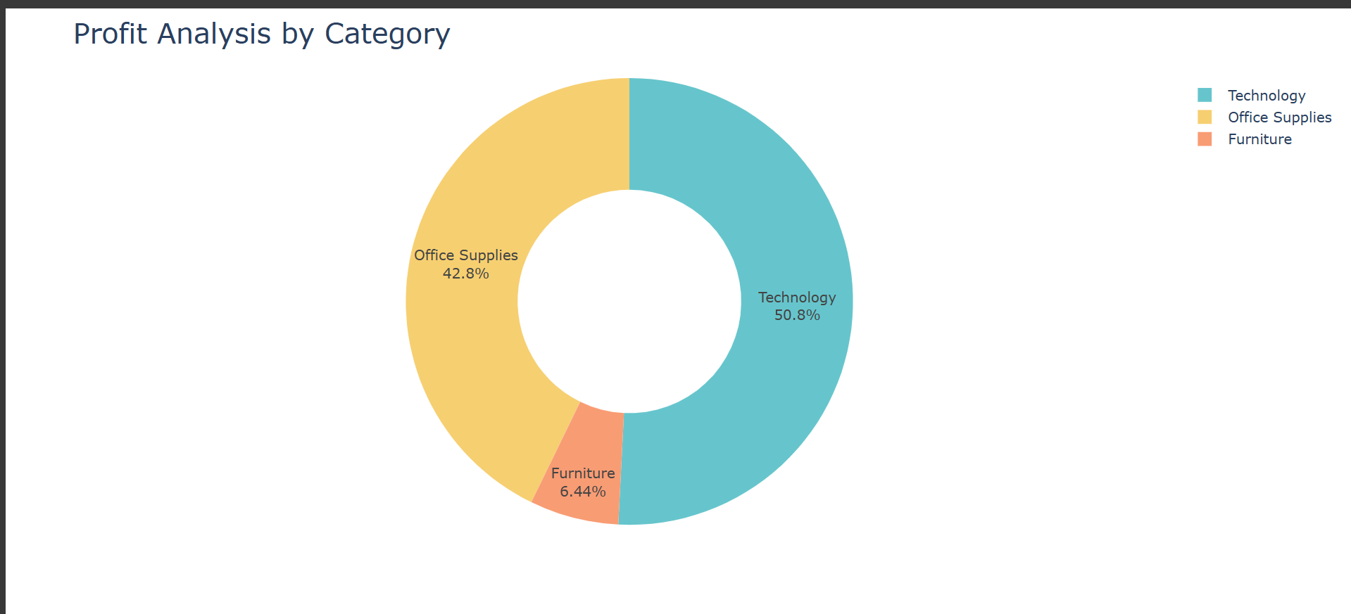

Office Supplies

6. Analyze the sales and profit by customer segment

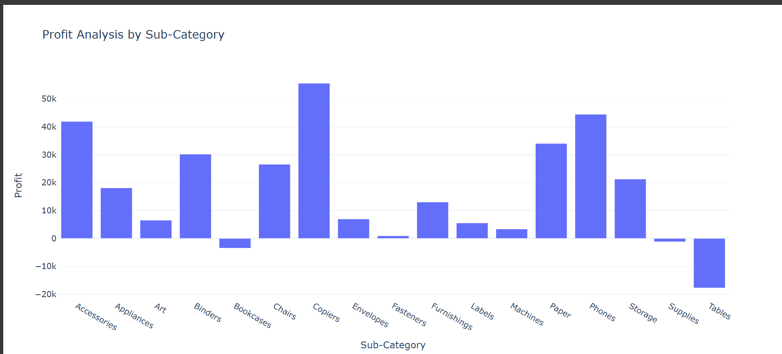

7. Analyze the sales to profit ratio

Segment Sales_to_Profit_Ratio

0 Consumer 8.659471

1 Corporate 7.677245

2 Home Office 7.125416